University of Engineering and Technology, Lahore


Department of Computer Science
Project Title:
Real-time Collaborative Network Monitoring
and Alert Dashboard
Submitted By:
- Name 1 (Roll No.)
- Name 2 (Roll No.)
- Name 3 (Roll No.)
Submitted To: Professor Name
Date: June 07, 2026

Table of Contents
Section | Page
1. Introduction | 3
2. Problem Statement | 4
3. System Architecture | 5
4. Protocol Design | 7
5. Implementation Details | 8
6. Features List | 11
7. Challenges & Solutions | 12
8. Code, Output & Explanation | 13
9. Testing & Results | 18
10. CLO Alignment | 21
11. Conclusion | 22
References | 23
1. Introduction
Network monitoring is an important part of computer networks because administrators must know when a router, server, service or link is behaving abnormally. In a real Network Operations Center, tools such as Nagios and PRTG collect events, show active devices and alert operators when a problem needs immediate action.
This project implements the same basic idea on a small scale using Python socket programming. Multiple clients connect to one central server over TCP. The clients can broadcast status updates, send emergency alerts, join category-based monitoring rooms, exchange private incident messages and share log files or screenshots.
The main problem solved by this system is coordination. When several users are watching simulated network events, they need a common dashboard where important updates arrive in real time. This makes the project useful for understanding application-layer message design, transport-layer reliability, concurrency and event-driven communication.
- Real world use: network labs, help desk rooms, NOC dashboards and incident response teams.
- Main networking concept: client-server communication over TCP.
- Main programming concept: threads for handling many clients at the same time.
2. Problem Statement
The assignment requires students to design and develop a real-time Collaborative Network Monitoring and Alert Dashboard using socket programming. The system must allow multiple connected clients, more than three devices, to monitor, share and respond to simulated network events over a LAN or Wi-Fi network.
Required functions include multi-client connectivity, real-time alert broadcasting, active client node display with hostnames and IP addresses, event log sharing, group monitoring rooms, private direct communication and simulated voice or text emergency alerts.
In our implementation, the above requirements are handled by a threaded Python TCP server and two client interfaces: a GUI dashboard for normal operation and a CLI client for quick demonstrations. The system can be demonstrated on one laptop by opening one server terminal and three client terminals.
3. System Architecture
The architecture follows a client-server model. The server is the central monitoring point. All clients connect to it and send JSON messages over TCP. The server keeps the active node list, routes room messages, forwards private messages and broadcasts emergency alerts.
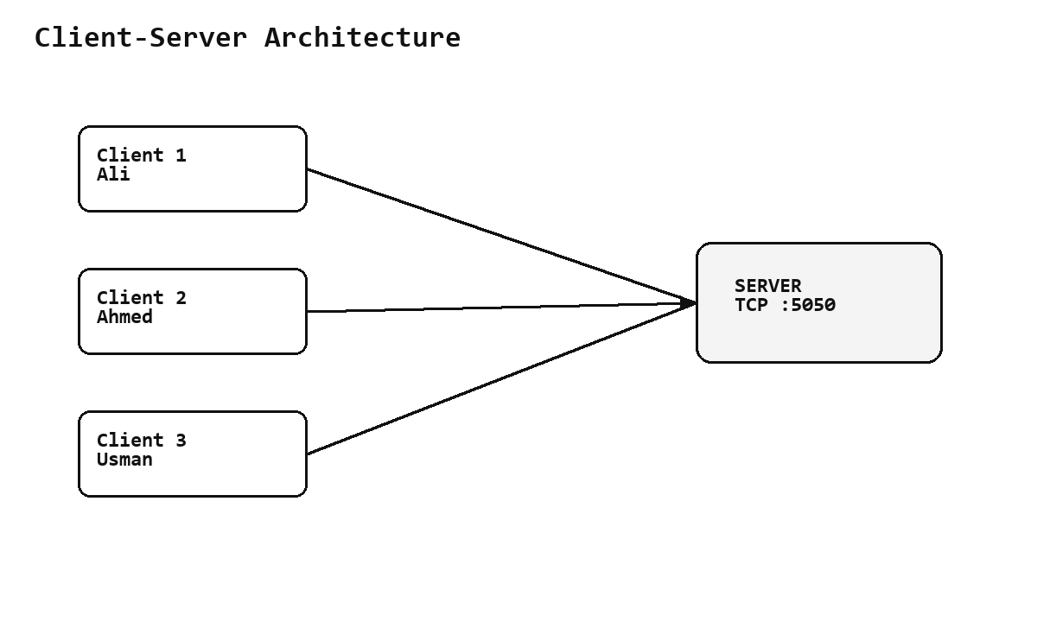
Even when all terminals run on the same PC, the design still behaves like a LAN model because every client opens its own socket connection to the server. On a real Wi-Fi network, other laptops can connect by using the server laptop IP address instead of 127.0.0.1.
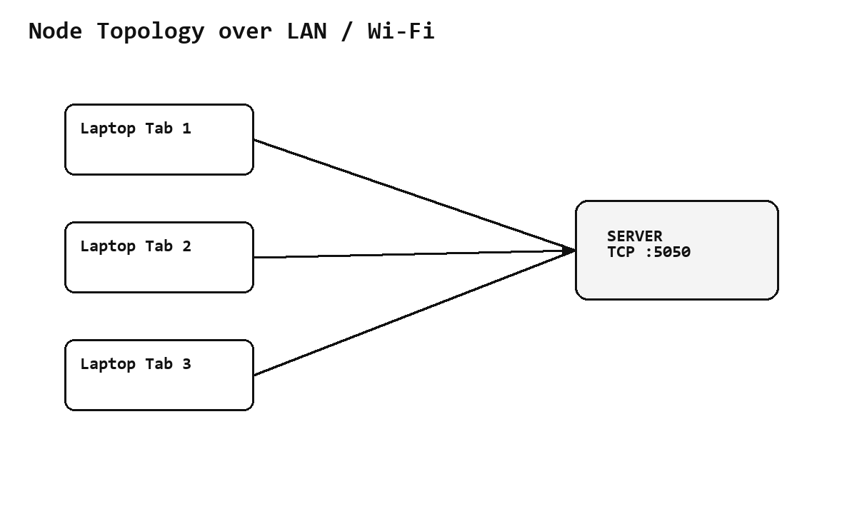
4. Protocol Design
TCP was selected instead of UDP because the dashboard needs reliable delivery. Alerts, private messages and shared files should not be silently lost. TCP also preserves byte stream ordering, which makes the newline-delimited JSON application protocol simple to implement.
- Application layer: JSON messages such as hello, alert, private, room_message, file, nodes_request, ping and pong.
- Transport layer: TCP sockets with server port 5050.
- Message framing: every JSON object is encoded in UTF-8 and terminated by a newline.
- Reliability reason: TCP provides retransmission, ordered delivery and connection state.
Example message format: {"type":"alert", "text":"CPU usage crossed 90 percent"}. For files, the client reads the file bytes and sends a Base64 encoded payload with filename and size metadata.
5. Implementation Details

5.1 Server Side
The server opens a TCP socket, binds it to port 5050 and listens for incoming client connections. Every accepted client is handled in a separate thread. A shared dictionary stores client names, hostnames, IP addresses, connected time and subscribed rooms. A lock is used whenever shared state is read or updated.

5.2 Client Side
The GUI client uses Tkinter. It has controls for connecting to the server, sending broadcast messages, emergency alerts, joining rooms, sending private messages, sharing files and viewing active nodes. The CLI client uses command-style input so the demo can be shown quickly in terminals.

5.3 Group Rooms
The rooms are CPU, Bandwidth and Security. A client can join or leave any room. Room messages are only delivered to clients subscribed to that room, which is similar to alert categories in real monitoring tools.

5.4 Private Messaging
For private communication, the sender provides the target client name. The server searches the active client table and forwards the private payload only to the target and the sender for confirmation. Other clients do not receive that message.

5.5 File Sharing
The file-sharing feature supports text logs, screenshots and short videos. For the demo, small files are encoded with Base64 and sent through the same TCP connection. The server stores a copy and broadcasts the file metadata and payload to connected clients.

5.6 Emergency Alerts
Emergency alerts use a separate message type. In the GUI client, the local notification bell is triggered and the log line is highlighted. In CLI mode, the alert is printed with an EMERGENCY label so it is easy to see during presentation.

5.7 Code Structure
File | Purpose
server.py | Accepts TCP clients, maintains active node state, manages rooms, private chat, alerts and file forwarding.
client_gui.py | Tkinter dashboard for live monitoring, alerts, nodes, private chat, rooms, latency and file sharing.
client_cli.py | Terminal client for fast presentation and command-based testing.
protocol.py | Shared JSON send/receive helpers and newline framing logic.
test_integration.py | Automated test covering the required communication features.
6. Features List
- Multi-client connectivity for three or more clients.
- Real-time broadcasting of status updates and alert notifications.
- Active nodes display with IP address and hostname.
- File and log sharing between clients.
- Group monitoring rooms for CPU, Bandwidth and Security alerts.
- Private direct communication between two selected clients.
- Emergency alert system with highlighted notification.
- Optional feature: GUI dashboard and latency ping metric.
7. Challenges & Solutions
Challenge | Solution Applied
Multiple clients at the same time | A separate thread is created for every client connection.
Shared active node state | A lock protects the dictionary containing connected clients and room subscriptions.
Room subscription management | A set of room names is stored with every client record.
Client disconnect handling | Socket errors and empty reads are handled with try/except and cleanup.
File transfer | Files are transferred as Base64 payloads and stored by the server.
8. Code, Output & Explanation
This section shows the main code blocks used in the project, their expected output and a short explanation. The complete executable source code files are also submitted separately in the project folder.

8.1 Protocol Helper Code
Code:
import json
import socket
from typing import Any, Dict
ENCODING = "utf-8"
def send_json(sock: socket.socket, payload: Dict[str, Any]) -> None:
data = json.dumps(payload, ensure_ascii=False).encode(ENCODING) + b"\n"
sock.sendall(data)
def recv_json(buffer: bytes, chunk: bytes):
buffer += chunk
messages = []
while b"\n" in buffer:
line, buffer = buffer.split(b"\n", 1)
if line.strip():
messages.append(json.loads(line.decode(ENCODING)))
return buffer, messages
def peer_label(sock: socket.socket) -> str:
try:
host, port = sock.getpeername()
return f"{host}:{port}"
except OSError:
return "disconnected"
Output:
JSON message sent successfully over TCP socket.
Receiver reads newline-delimited JSON and converts it back into a Python dictionary.
Explanation:
The protocol file keeps the send and receive logic common for the server and clients. Every message is JSON encoded in UTF-8 and ended with a newline, which makes message framing simple and reliable over TCP.

8.2 Server Connection and Threading Code
Code:
class MonitoringServer:
def __init__(self, host: str, port: int, upload_dir: str = "server_received"):
self.host = host
self.port = port
self.upload_dir = upload_dir
self.clients: Dict[socket.socket, ClientInfo] = {}
self.lock = threading.RLock()
self.running = threading.Event()
os.makedirs(self.upload_dir, exist_ok=True)
def start(self) -> None:
self.running.set()
with socket.socket(socket.AF_INET, socket.SOCK_STREAM) as server:
server.setsockopt(socket.SOL_SOCKET, socket.SO_REUSEADDR, 1)
server.bind((self.host, self.port))
server.listen()
print(f"[SERVER] Real-time monitoring server listening on {self.host}:{self.port}")
print("[SERVER] Waiting for clients. Press Ctrl+C to stop.")
while self.running.is_set():
try:
client_sock, address = server.accept()
except OSError:
break
threading.Thread(
target=self.handle_client,
args=(client_sock, address),
daemon=True,
).start()
def handle_client(self, sock: socket.socket, address) -> None:
buffer = b""
info = None
try:
while True:
chunk = sock.recv(65536)
if not chunk:
break
buffer, messages = recv_json(buffer, chunk)
for message in messages:
if message.get("type") == "hello":
info = self.register_client(sock, message, address)
elif info:
self.route_message(sock, message)
except (ConnectionError, OSError, ValueError) as exc:
print(f"[SERVER] Client error from {peer_label(sock)}: {exc}")
finally:
self.disconnect(sock)
def register_client(self, sock: socket.socket, message, address) -> ClientInfo:
name = message.get("name", f"Client-{address[1]}").strip() or f"Client-{address[1]}"
hostname = message.get("hostname", "unknown")
info = ClientInfo(sock=sock, name=name, hostname=hostname, ip=address[0])
with self.lock:
self.clients[sock] = info
send_json(sock, {"type": "system", "text": f"Connected to monitoring server as {name}."})
send_json(sock, {"type": "rooms", "rooms": list(ROOMS)})
self.broadcast_system(f"{name} joined from {info.ip} ({hostname}).")
self.broadcast_nodes()
print(f"[SERVER] {name} connected from {info.ip} ({hostname})")
return info
def disconnect(self, sock: socket.socket) -> None:
with self.lock:
info = self.clients.pop(sock, None)
try:
sock.close()
except OSError:
pass
if info:
print(f"[SERVER] {info.name} disconnected.")
self.broadcast_system(f"{info.name} disconnected.")
self.broadcast_nodes()
Output:
[SERVER] Real-time monitoring server listening on 0.0.0.0:5050
[SERVER] Ali connected from 127.0.0.1
[SERVER] Ahmed connected from 127.0.0.1
[SERVER] Usman connected from 127.0.0.1
Explanation:
The server listens on TCP port 5050 and starts a new thread for every connected client. This allows multiple clients to stay online and exchange events at the same time without blocking the whole application.

8.3 Alert, Room, Private Chat and File Routing Code
Code:
def route_message(self, sock: socket.socket, message) -> None:
msg_type = message.get("type")
if msg_type == "broadcast":
self.broadcast_event(sock, message.get("text", ""), "status")
elif msg_type == "alert":
self.broadcast_event(sock, message.get("text", ""), "alert")
elif msg_type == "emergency":
self.broadcast_event(sock, message.get("text", ""), "emergency")
elif msg_type == "join_room":
self.join_room(sock, message.get("room", ""))
elif msg_type == "leave_room":
self.leave_room(sock, message.get("room", ""))
elif msg_type == "room_message":
self.room_message(sock, message.get("room", ""), message.get("text", ""))
elif msg_type == "private":
self.private_message(sock, message.get("to", ""), message.get("text", ""))
elif msg_type == "file":
self.handle_file(sock, message)
elif msg_type == "nodes_request":
self.send_nodes(sock)
elif msg_type == "ping":
send_json(sock, {"type": "pong", "sent_at": message.get("sent_at", time.time())})
def broadcast_event(self, sender_sock: socket.socket, text: str, level: str) -> None:
sender = self.clients.get(sender_sock)
if not sender or not text.strip():
return
payload = {
"type": "event",
"level": level,
"from": sender.name,
"text": text.strip(),
"time": time.strftime("%H:%M:%S"),
}
self.send_to_all(payload)
print(f"[{level.upper()}] {sender.name}: {text.strip()}")
def join_room(self, sock: socket.socket, room: str) -> None:
room = self.normalize_room(room)
info = self.clients.get(sock)
if not info or not room:
return
with self.lock:
info.rooms.add(room)
send_json(sock, {"type": "system", "text": f"You joined {room} room."})
self.room_notice(room, f"{info.name} joined {room} room.")
def leave_room(self, sock: socket.socket, room: str) -> None:
room = self.normalize_room(room)
info = self.clients.get(sock)
if not info or not room:
return
with self.lock:
info.rooms.discard(room)
send_json(sock, {"type": "system", "text": f"You left {room} room."})
self.room_notice(room, f"{info.name} left {room} room.")
def room_message(self, sock: socket.socket, room: str, text: str) -> None:
room = self.normalize_room(room)
sender = self.clients.get(sock)
if not sender or not room or not text.strip():
return
payload = {
"type": "room",
"room": room,
"from": sender.name,
"text": text.strip(),
"time": time.strftime("%H:%M:%S"),
}
with self.lock:
targets = [c.sock for c in self.clients.values() if room in c.rooms]
for target in targets:
self.safe_send(target, payload)
print(f"[ROOM:{room}] {sender.name}: {text.strip()}")
def private_message(self, sock: socket.socket, target_name: str, text: str) -> None:
sender = self.clients.get(sock)
if not sender or not target_name.strip() or not text.strip():
return
target = self.find_by_name(target_name.strip())
if not target:
send_json(sock, {"type": "system", "text": f"Private target '{target_name}' is not online."})
return
payload = {
"type": "private",
"from": sender.name,
"to": target.name,
"text": text.strip(),
"time": time.strftime("%H:%M:%S"),
}
self.safe_send(target.sock, payload)
self.safe_send(sock, payload)
print(f"[PRIVATE] {sender.name} -> {target.name}: {text.strip()}")
def handle_file(self, sock: socket.socket, message) -> None:
sender = self.clients.get(sock)
if not sender:
return
filename = os.path.basename(message.get("filename", "shared_file.bin"))
file_bytes = base64.b64decode(message.get("data", ""))
saved_name = f"{int(time.time())}_{sender.name}_{filename}".replace(" ", "_")
saved_path = os.path.join(self.upload_dir, saved_name)
with open(saved_path, "wb") as file_obj:
file_obj.write(file_bytes)
payload = {
"type": "file",
"from": sender.name,
"filename": filename,
"size": len(file_bytes),
"data": message.get("data", ""),
"time": time.strftime("%H:%M:%S"),
}
self.send_to_all(payload)
print(f"[FILE] {sender.name} shared {filename} ({len(file_bytes)} bytes)")
Output:
[ALERT] Ali: CPU usage crossed 90 percent
[ROOM:CPU] Ali: CPU room incident opened
[PRIVATE] Usman -> Ahmed: Please verify firewall logs
[FILE] Ali shared cpu_fault_log.txt (209 bytes)
Explanation:
This block contains the main server-side routing logic. It checks the message type and then forwards the event to all clients, a specific room, a private user or all clients for shared files.

8.4 GUI Client Code
Code:
class MonitoringClientGUI(tk.Tk):
def __init__(self):
super().__init__()
self.title("Collaborative Network Monitoring Dashboard")
self.geometry("980x650")
self.minsize(900, 580)
self.sock = None
self.buffer = b""
self.inbox = queue.Queue()
self.connected = False
self.rooms = ["CPU", "Bandwidth", "Security"]
self.configure(bg="#f7f7f7")
self.build_ui()
self.after(100, self.process_inbox)
def build_ui(self):
style = ttk.Style(self)
style.configure("TButton", padding=6)
style.configure("TLabel", background="#f7f7f7", font=("Segoe UI", 10))
style.configure("Header.TLabel", font=("Segoe UI", 16, "bold"))
top = ttk.Frame(self, padding=12)
top.pack(fill=tk.X)
ttk.Label(top, text="Network Monitoring Dashboard", style="Header.TLabel").grid(row=0, column=0, sticky="w", columnspan=2)
ttk.Label(top, text="Server").grid(row=1, column=0, sticky="w")
self.host_var = tk.StringVar(value="127.0.0.1")
self.port_var = tk.StringVar(value="5050")
self.name_var = tk.StringVar(value="")
ttk.Entry(top, textvariable=self.host_var, width=16).grid(row=1, column=1, padx=4)
ttk.Entry(top, textvariable=self.port_var, width=7).grid(row=1, column=2, padx=4)
ttk.Label(top, text="Name").grid(row=1, column=3, padx=(14, 0))
ttk.Entry(top, textvariable=self.name_var, width=14).grid(row=1, column=4, padx=4)
self.connect_btn = ttk.Button(top, text="Connect", command=self.connect)
self.connect_btn.grid(row=1, column=5, padx=8)
self.status_var = tk.StringVar(value="Offline")
ttk.Label(top, textvariable=self.status_var).grid(row=1, column=6, sticky="w")
main = ttk.PanedWindow(self, orient=tk.HORIZONTAL)
main.pack(fill=tk.BOTH, expand=True, padx=12, pady=(0, 12))
left = ttk.Frame(main, padding=8)
right = ttk.Frame(main, padding=8)
main.add(left, weight=3)
main.add(right, weight=1)
self.log = tk.Text(left, height=20, wrap=tk.WORD, bg="white", fg="#111111", font=("Consolas", 10))
self.log.pack(fill=tk.BOTH, expand=True)
self.log.tag_config("alert", foreground="#b42318", font=("Consolas", 10, "bold"))
self.log.tag_config("emergency", foreground="#ffffff", background="#b42318", font=("Consolas", 10, "bold"))
self.log.tag_config("private", foreground="#53389e")
self.log.tag_config("room", foreground="#175cd3")
self.log.tag_config("system", foreground="#475467")
send_row = ttk.Frame(left)
send_row.pack(fill=tk.X, pady=(8, 0))
self.message_var = tk.StringVar()
ttk.Entry(send_row, textvariable=self.message_var).pack(side=tk.LEFT, fill=tk.X, expand=True)
ttk.Button(send_row, text="Broadcast", command=self.send_broadcast).pack(side=tk.LEFT, padx=4)
ttk.Button(send_row, text="Alert", command=self.send_alert).pack(side=tk.LEFT, padx=4)
ttk.Button(send_row, text="Emergency", command=self.send_emergency).pack(side=tk.LEFT, padx=4)
ttk.Label(right, text="Active Nodes", style="Header.TLabel").pack(anchor="w")
self.nodes = tk.Listbox(right, height=8, exportselection=False)
self.nodes.pack(fill=tk.X, pady=(4, 10))
ttk.Button(right, text="Refresh Nodes", command=lambda: self.send({"type": "nodes_request"})).pack(fill=tk.X)
room_box = ttk.LabelFrame(right, text="Group Rooms", padding=8)
room_box.pack(fill=tk.X, pady=10)
self.room_var = tk.StringVar(value="CPU")
ttk.Combobox(room_box, values=self.rooms, textvariable=self.room_var, state="readonly").pack(fill=tk.X)
ttk.Button(room_box, text="Join Room", command=self.join_room).pack(fill=tk.X, pady=(6, 2))
ttk.Button(room_box, text="Leave Room", command=self.leave_room).pack(fill=tk.X, pady=2)
ttk.Button(room_box, text="Send Room Message", command=self.room_message).pack(fill=tk.X, pady=2)
private_box = ttk.LabelFrame(right, text="Private Chat", padding=8)
private_box.pack(fill=tk.X, pady=10)
self.private_to_var = tk.StringVar()
ttk.Entry(private_box, textvariable=self.private_to_var).pack(fill=tk.X)
ttk.Button(private_box, text="Send Private", command=self.private_message).pack(fill=tk.X, pady=(6, 0))
file_box = ttk.LabelFrame(right, text="File / Log Sharing", padding=8)
file_box.pack(fill=tk.X, pady=10)
ttk.Button(file_box, text="Share File", command=self.share_file).pack(fill=tk.X)
ttk.Button(file_box, text="Ping Latency", command=lambda: self.send({"type": "ping", "sent_at": time.time()})).pack(fill=tk.X, pady=(6, 0))
def connect(self):
# ... remaining code is included in the submitted .py file ...
Output:
GUI opens with server 127.0.0.1 and port 5050.
Name field is blank.
User enters a name, clicks Connect, and dashboard status changes from Offline to Online.
Explanation:
The GUI client gives a dashboard-style interface for the project. The name field is intentionally blank now so every user can enter their own client name during the demo.

8.5 CLI Client Command Code
Code:
def repl(self) -> None:
print("Commands: /alert text | /emergency text | /join room | /leave room | /room room text")
print(" /pm name text | /file path | /nodes | /ping | /quit")
while self.running:
try:
line = input("> ").strip()
except (EOFError, KeyboardInterrupt):
break
if not line:
continue
if line == "/quit":
break
self.handle_command(line)
self.running = False
self.sock.close()
def handle_command(self, line: str) -> None:
if line.startswith("/alert "):
send_json(self.sock, {"type": "alert", "text": line[7:]})
elif line.startswith("/emergency "):
send_json(self.sock, {"type": "emergency", "text": line[11:]})
elif line.startswith("/join "):
send_json(self.sock, {"type": "join_room", "room": line[6:]})
elif line.startswith("/leave "):
send_json(self.sock, {"type": "leave_room", "room": line[7:]})
elif line.startswith("/room "):
_, room, text = line.split(" ", 2)
send_json(self.sock, {"type": "room_message", "room": room, "text": text})
elif line.startswith("/pm "):
_, target, text = line.split(" ", 2)
send_json(self.sock, {"type": "private", "to": target, "text": text})
elif line.startswith("/file "):
self.send_file(line[6:].strip('"'))
elif line == "/nodes":
send_json(self.sock, {"type": "nodes_request"})
elif line == "/ping":
send_json(self.sock, {"type": "ping", "sent_at": time.time()})
else:
send_json(self.sock, {"type": "broadcast", "text": line})
Output:
Commands:
/alert CPU usage crossed 90 percent
/join CPU
/room CPU CPU room incident opened
/pm Ahmed Please verify firewall logs
/file sample_logs/cpu_fault_log.txt
Explanation:
The CLI client is useful for presentation because commands can be typed quickly in separate terminals. It supports broadcast, emergency, room, private chat, file sharing, node list and latency testing.

8.6 Automated Testing Code
Code:
def main():
port = 5061
server = MonitoringServer("127.0.0.1", port, upload_dir="test_received")
threading.Thread(target=server.start, daemon=True).start()
time.sleep(0.4)
ali = BotClient("Ali", port)
ahmed = BotClient("Ahmed", port)
usman = BotClient("Usman", port)
clients = [ali, ahmed, usman]
assert wait_until(lambda: all(c.saw("nodes", "Ali") for c in clients)), "nodes not broadcast"
ali.send({"type": "alert", "text": "CPU usage crossed 90 percent"})
assert wait_until(lambda: all(c.saw("event", "CPU usage crossed") for c in clients)), "alert missing"
ali.send({"type": "join_room", "room": "CPU"})
ahmed.send({"type": "join_room", "room": "CPU"})
time.sleep(0.2)
ali.send({"type": "room_message", "room": "CPU", "text": "CPU room incident opened"})
assert wait_until(lambda: ahmed.saw("room", "CPU room incident")), "room message missing"
usman.send({"type": "private", "to": "Ahmed", "text": "Please verify firewall logs"})
assert wait_until(lambda: ahmed.saw("private", "firewall logs")), "private message missing"
sample_path = os.path.join("sample_logs", "cpu_fault_log.txt")
with open(sample_path, "rb") as file_obj:
data = base64.b64encode(file_obj.read()).decode("ascii")
ali.send({"type": "file", "filename": "cpu_fault_log.txt", "data": data})
assert wait_until(lambda: all(c.saw("file", "cpu_fault_log.txt") for c in clients)), "file share missing"
ali.send({"type": "ping", "sent_at": time.time()})
assert wait_until(lambda: ali.saw("pong", "sent_at")), "pong missing"
for client in clients:
client.close()
print("Integration test passed: nodes, broadcast alert, rooms, private chat, file sharing, and ping.")
if __name__ == "__main__":
main()
Output:
Integration test passed: nodes, broadcast alert, rooms, private chat, file sharing, and ping.
Explanation:
The integration test starts the server and connects three bot clients. It proves that the important project requirements are working before the live presentation.
9. Testing & Results
Testing was performed on one PC using separate terminals for the server and clients. The automated integration test also verified the main flows: active nodes, alert broadcasting, room message delivery, private chat, file sharing and ping response.
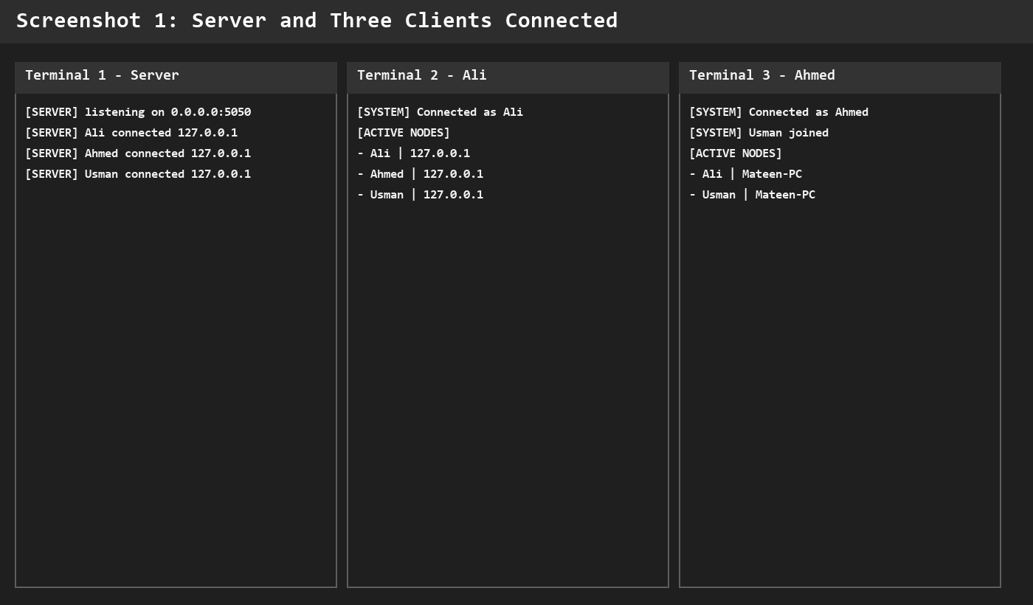

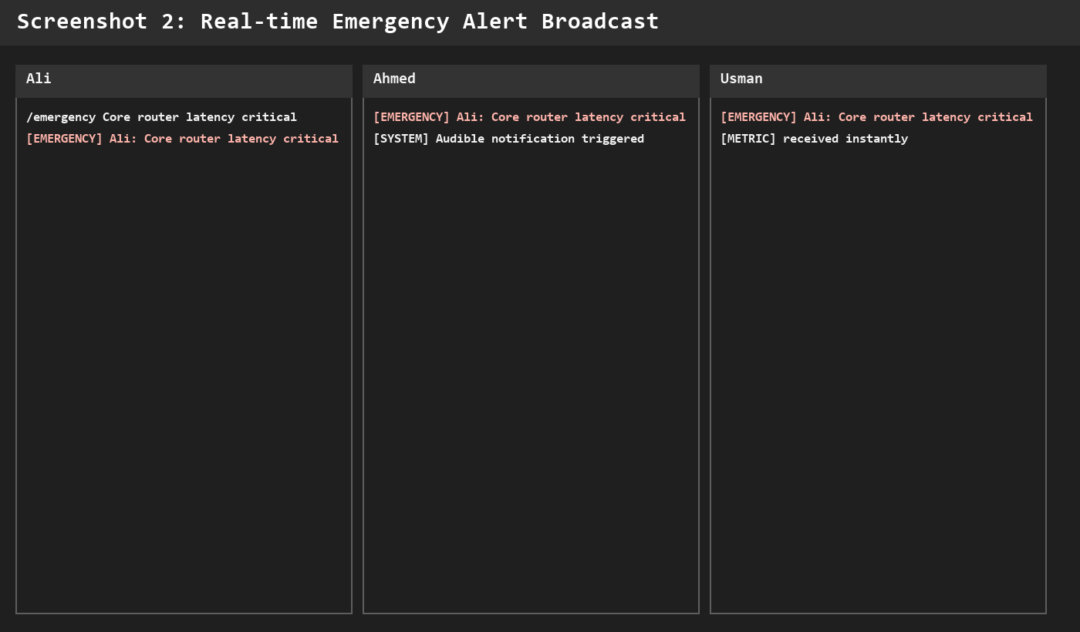
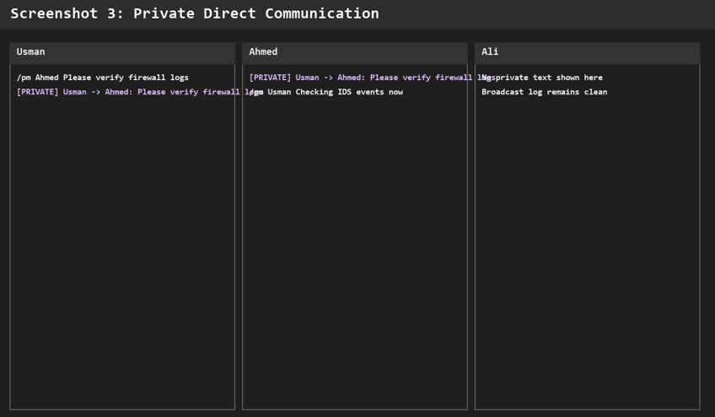
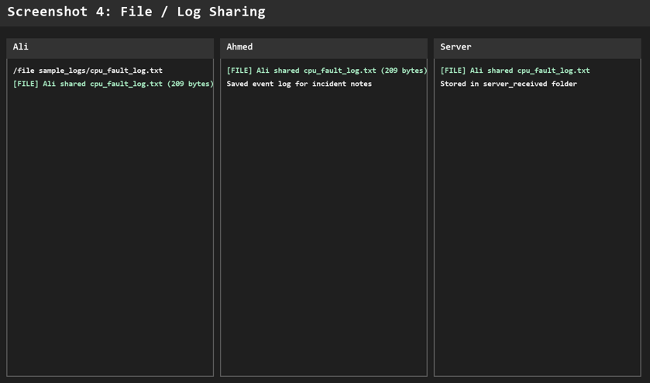
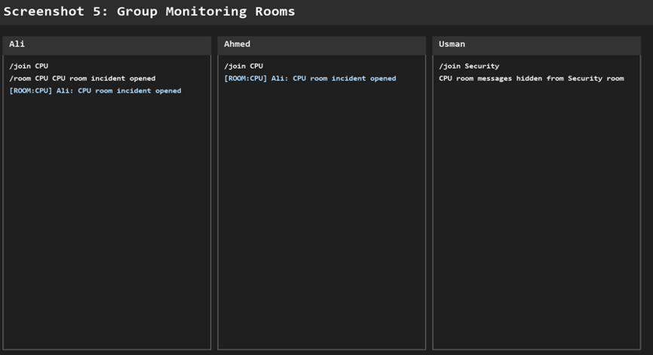
Performance observations: on local testing, the ping response was normally below a few milliseconds because all clients were on the same PC. The threaded server handled three simultaneous clients smoothly. Since TCP is used, packet loss is handled by the transport layer through retransmission.
10. CLO Alignment
CLO 3 is about analyzing network protocols based on application and transport layer performance requirements. This project aligns with CLO 3 because it required a protocol choice, application message format design and concurrency decisions.
- TCP was selected after comparing reliability needs with UDP behavior.
- Application-layer JSON messages were designed for alerts, rooms, private chat, file sharing and node discovery.
- Threading was used to support concurrent clients without blocking the whole server.
- The system demonstrates interdependent components: server, clients, rooms, files, alerts and active node display.
11. Conclusion
The project successfully implements a real-time collaborative network monitoring and alert dashboard using Python sockets and threading. It supports multi-client connectivity, active node display, broadcast alerts, group rooms, private chat, file/log sharing and emergency notifications.
The system is suitable for classroom demonstration because it can run completely on one laptop using multiple terminals. Future improvements can include TLS encryption, persistent chat history, user authentication, larger chunk-based file transfer and a web dashboard.
References
[1] Python Socket Programming Documentation
[2] Python Threading Documentation
[3] Behrouz A. Forouzan, Data Communications and Networking
[4] Nagios Documentation
[5] PRTG Network Monitor Documentation

Diagrams and Screenshots Evidence
This section contains the actual architecture diagrams and testing screenshots used as evidence for the project demonstration.
Architecture Diagrams


Testing Screenshots


